**Change Request**

**SAPERION, Pre-alert**

###### Project Info

**Project Name:** > SAPERION, Pre-alert

**Project Manager:** > Austin Liew

**IT / Solution:** > Marappan Manoharan(Mr)

**Operations:** > Air Freight, Export Ops.

###### Purpose of document

This document illustrates changes required to eradicate manual trigger of pre-alert with automated system to direct standard pre-alert to respective audience with defined correspondences.

###### Version Info

|  |  |  |  |
| --- | --- | --- | --- |
| **Version** | **Revision Date** | **Revision Description** | **Author** |
| 1.0 |  | Initial draft | Austin Liew |

###### Location of document

**Link:**

**Path:**

1 Description 4

2 Detail Requirements 6

3 References 18

4 Out Of Scope 18

5 Reasons for change 18

6 Impact on other project issues 18

7 Consequences if change is not approved 18

8 Estimated Effort 18

9 Impact on Project Plan 18

10 Appendix 19

###### Change Request

# Description

## To expand the use of Saperion with initial designed solely on billing purposes to encompassing pre-alert as an integral function of Saperion as multiple documents are available on the same platform.

### Background

Today, correspondences needed to generate pre-alert to respective audience is being scanned to ODM & send to respective ops personnel inbox. Ops would then retrieve necessary correspondences & draft pre-alert email to respective audience with customize email content & send.

Note: Many customer would have various requirement or expectation of pre-alert email with various types of doc or content in email.

### Ideal/Propose

Enabling auto pre-alert with a standardized rule defined in Saperion to default audience governs by Saperion. Pre-alert source shall be the same as of present set up in Saperion.

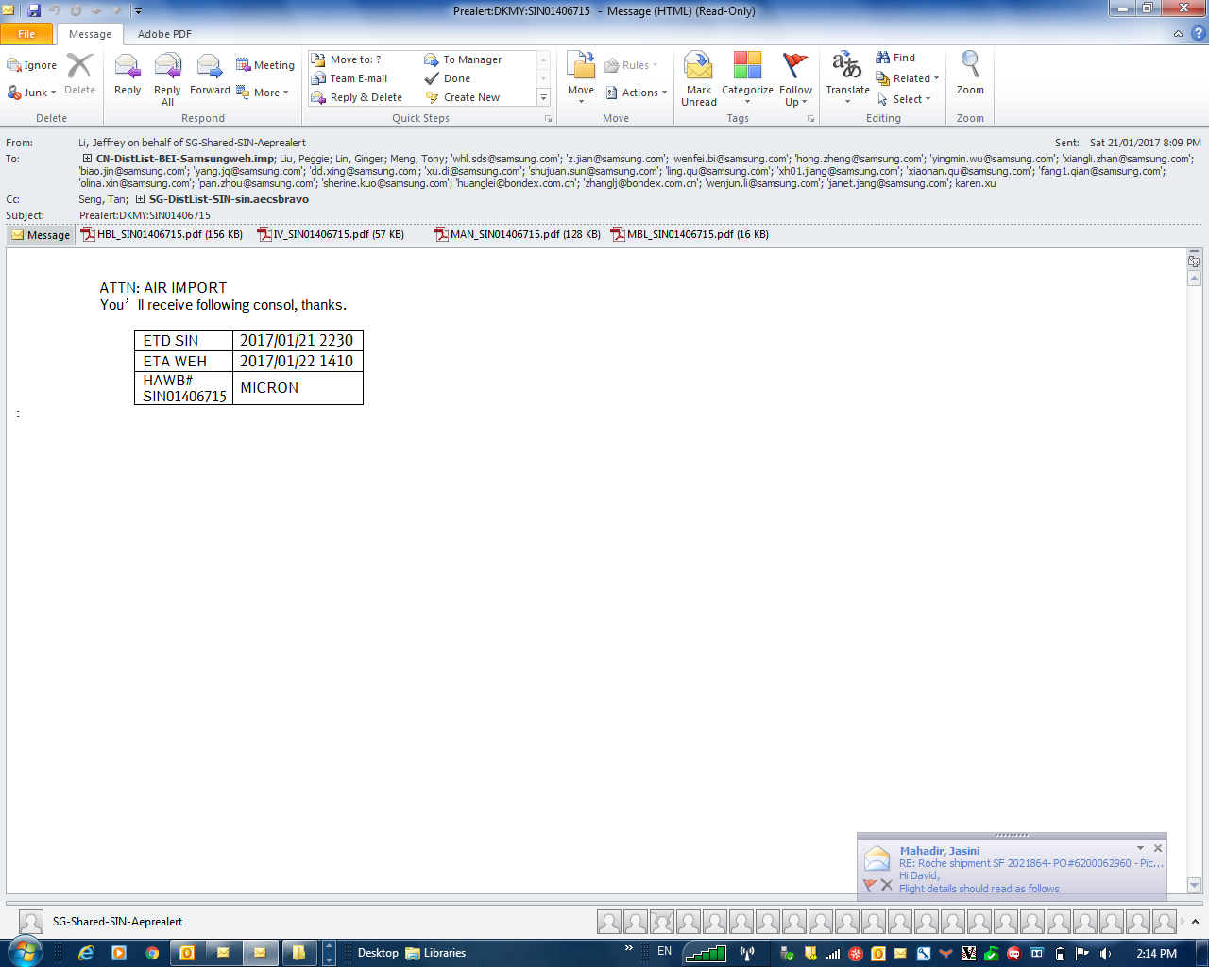

### In Scope

* New user & new organization structure/work group.
* Customer maintenance table for pre-alert requirement with minimal deviation.
* Data source or string from respective channel or system such as Procars or ODM.
* Auto email title & content. Customization is expected but aims to be minimal.
* Super user access of various maintenance to ease future changes in various maintenance table such as the following scenario but not limited to,
  + Change of routing
  + Add user or audiences
  + Change of pre-alert requirement on correspondences such as adding other doc in pre-alert
  + Change of e-mail content
* Reports of pre-alert volumes & leadtime from pre-alert sent to “departure” (Procars feed presently available)

### Definition

HAWB: House Air Way Bill

### Summary of Changes

|  |  |  |  |  |
| --- | --- | --- | --- | --- |
| **S/N** | **Sec** | **Topic** | **System Changes** | **Operational Changes** |
| 1 |  | Auto Pre-alert | Enabling auto pre-alert | Yes, eliminating manual process. |
|  |  |  |  |  |

# Detail Requirements

* 1. Audience list shall be differentiated by “to” & “cc” in maintenance, this is to allow flexibility in changes as well as control should we decided to restrict to a particular group of audience only as any given time. Scenario is assuming Schenker internal audience being “cc” & external audience being “to”, we may deactivate “to” to keep the pre-alert exclusive to Schenker for the purpose of test, control or customization.
  2. Title begins with shipper, follow by consignee, HAWB & destination with standard attachment of “HAWB” from Procars upon execution & “Commin”, from ODB upon scanning.
  3. Email contains shall be as follow with highlighted in red being variables of each shipment.

Dear Sir/Madam,  
  
Please find the above appended pre-alert for your reference.   
  
Thank you.  
  
**FliGHT:CA976/18 – CA4110/19  
ETD:0930H / 1900H  
ETA: 1530H / 2215H  
Package information: 1PLT**

# References

# Out Of Scope

Undefined yet

# Reasons for change

Improve efficiency.

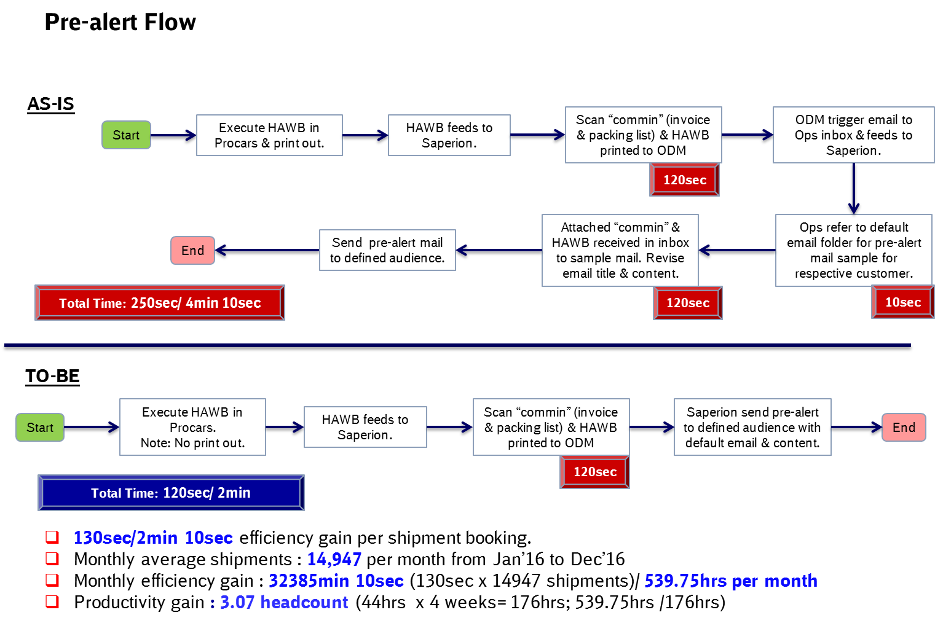

# Impact on other project issues

NA

# Consequences if change is not approved

# Estimated Effort

TBD

# Impact on Project Plan

# Appendix

###### Approval

|  |  |  |  |
| --- | --- | --- | --- |
| **Steering Committee:** | > | **Date:** | > |